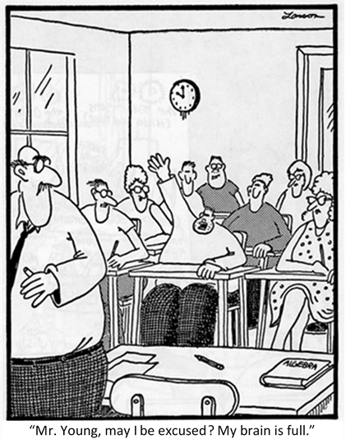
2019 APES Review  ** Daily plans subject to change ** |  |  |  | 4/12  - AP Exam tab  - APES Topic Outline  - Organize binders  2008 AP Exam
4/15  2008 AP Exam  Past Unit Exams | 4/16  2008 Exam Answers/  Diagnostics | 4/17  Math Tutorial  Math Review  Half-Life Discussion | 4/18  Continue Math  Past Unit Exams | 4/19  2010 AP Exam
4/22  Major Environmental  Pollutants  2010 Exam  FRQ Tips | 4/23  FRQ Prep using the College Board website | 4/24  2010 Exam Answers | 4/25  Environmental Laws  Environmental  Case Studies  Past Unit Exams | 4/26  2016 AP Exam
4/29  2016 AP Exam  Past Unit Exams | 4/30  2016 Exam Answers/  Diagnostics | 5/1  Specific Topical Review  Exam Strategies/  Tips | 5/2  APES FINAL  #1-50 | 5/3  APES FINAL  #51-100
5/6  APES  NATIONAL  EXAM  12pm | AP EXAM Study session  Sunday, May 5  1pm – 5pm  Look over APES final, review all material, practice FRQ’s

AP ENVIRONMENTAL SCIENCE
NATIONAL EXAM

Monday, May 6th
ELSC on Edgewood Rd.

Exam STARTS at 12pm
** Be there by 11:30am – 11:45 at the latest**

Study Materials You Already Have:
- APES Topic Outline
- Study guides for units 1-11
- PowerPoints for chapters 1-19
- Any topic-specific assignments or activities from throughout the year
- “AP Exam Info” tab on class website -- www.kennedyapes.weebly.com – Info about the exam (location, time, etc.), there are also many review resources available, including Quizlet flash cards.

Study Materials Made Available to You:
- Units 1-11 Exams
- 2008 Released Exam and diagnostic guide
- 2010 Released Exam
- 2016 Released Exam and analysis guide
- 100 Things You Should Know…
- Environmental Pollutants Lists
- Preparing for FRQs
- APES Math Tutorial
- APES Mathematics Review
- Spark Charts – Environmental Studies
- APES Legislation Review

Strategies for Review

- Start with the list of major topics. This is what the test-makers say will be on the exam. Decide how best to summarize/learn/remember each topic. Highlight and focus on the topics that you feel need the most work.

- Make and stick to a study schedule. Set aside specific times to study with specific topics that you plan to review and what you are going to do to review these topics.

- Be able to describe each main topic based on all materials available to you such as: your notes outlines, study guides, labs and activities, textbook, the internet, PowerPoint notes, and the links I provide on our class website.

- Go through Unit Exams. **Only available during class.** Read through ALL questions (even those you answered correctly). Focus on errors and make a list of topics to review.

- Make flash cards of the terms/concepts you don’t know.

- Connect and recognize similarities and differences between the topics.

- Review/practice how to set up math problems for units to cancel out (NO calculators).

- Form a productive study group and arrange convenient meeting times. Have intelligent conversations with your study group and push each other to make connections between topics.

- Take and analyze your performance on both the 2008, 2010, and 2016 released exams.

- Critically evaluate how to improve for the AP exam using the Exam Diagnostic Guides.

- Practice writing the previous AP Exam FRQ’s and analyze how they are graded: https://apcentral.collegeboard.org/courses/ap-environmental-science/exam

