Isolated wolves of Isle Royale in peril
Article by: JOSEPHINE MARCOTTY , Star Tribune, May 7, 2012
Should naturalists intervene to restore a famous wolf population?
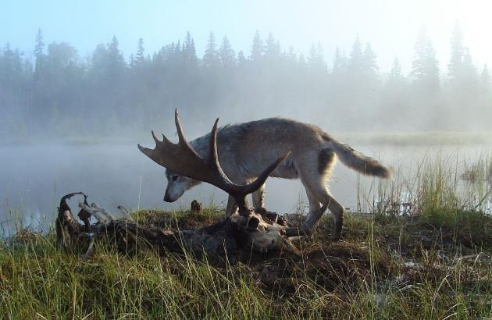
During a cold winter in the late 1940s, wolves made a 20-mile journey across an ice bridge that had formed between the North Shore of Lake Superior and Isle Royale.
Ever since, their descendants have lived and died on the wooded island in sync with the moose that became their prey, in a natural drama that would become the longest and most famous predator study ever conducted.
But soon it could end.
Only nine wolves are left on Isle Royale, the lowest number ever recorded. Only one is known to be female.
Now the National Park Service faces a precedent-setting decision: Whether to preempt nature and bring in new wolves to replenish the pack in the nation's wildest national park, or to stick with a longstanding hands-off philosophy that guides its mission in all national parks -- even if that means extinction for the wolves of Isle Royale.
That ethically complex decision will ripple across the entire National Park system, according to Phyllis Green, superintendent of Isle Royale. Many of the country's most treasured natural places are becoming islands, ringed in by development, private landowners and agriculture. All are affected by global warming, invasive species and pollution, she said.
"The hand of man is everywhere in this world," she said. "If an island is being turned into an ark, which animals get invited onto the boat?"
Yet even debate itself is an acknowledgement that the island and its wolves are now largely symbols of an untouched wilderness that no longer exists. The wolves have declined in part because, thanks to global warming, ice bridges are now exceedingly rare. Roads and development along Lake Superior's North Shore act as a barrier to all wildlife that might wander across the few that form. And a disease that almost wiped out the wolves in the 1980s was somehow brought to the island by humans or their dogs.
"The idea of pristine nature being out there is no more," said Doug Smith, a biologist who runs the wolf program at Yellowstone National Park. "You have to have more intervention if you want to keep this looking like it used to. It's a sad fact, to be honest."
Prey and predator
No one knows how moose got onto Isle Royale. Presumably, researchers say, they either swam or were brought there by humans sometime in the early part of the 20th century. Without the predators they faced on the mainland, their numbers soared to 3,000 or more within a few decades, decimating the vegetation on the 206-square-mile island before they crashed from starvation in the 1930s and again in the 1940s.
The cycle was so bad that managers of the island, which became a national park in the 1930s, contemplated bringing in wolves to control the moose -- while protecting them from a wolf extermination campaign then underway across the country. In 1952, four captive-raised wolves were brought to Isle Royale, even though wild wolves already had arrived on their own.
Three of the captive wolves were killed or removed after they became a nuisance, and the fourth disappeared.
But the wild wolves flourished. Their success was documented starting in 1958 by Durward Allen, a Purdue University ecologist, who recognized the opportunity to study a perfect choreography of predator and prey in a bubble. There are no deer on the island, and smaller prey is limited. Moose make up 90 percent of the wolves' diet.
The two species kept each other in check for decades. Wolf numbers averaged 25, rising at one point to nearly 50. Rolf Peterson, a professor at Michigan Tech University in Houghton, Mich., took over the research in the 1970s.
Ten years later, the wolves were struck by parvovirus, a disease carried by dogs, and their number plummeted to 12, triggering concerns that the now-famous predators might go extinct. At that point, the Park Service first agreed to allow researchers to capture, test and radio-collar some of their subjects to better understand what was going on.
But in 1998, another wolf crossed the ice, an extraordinary event that researchers only discovered later through genetic analysis. He became the alpha wolf with remarkable affect. "His new genes were far superior," Peterson said. "He perked things up dramatically."
In the past decade, moose have declined by half on the island, likely as a result of warmer summers and winters, researchers say. That, combined with more disease and perhaps unidentified problems related to inbreeding, again pushed wolf numbers down to 21 by 2007, then 16 in 2011. And now nine.
A debate and a bet
Peterson said the only wolf he knows for sure to be female has almost certainly mated. "We saw the tracks in the snow," he said. If she produces a litter, and if one or more of the pups is female, then the wolves' fate could change, he said. David Mech, a wolf researcher for the U.S. Geological Service, said he thinks it's premature to worry about their demise and what do about it. "I'm betting on the wlves."
Nevertheless, the question has touched off a debate among naturalists. Other researchers, including Peterson, say that nine wolves might not prevail even if new females are born this year. "We are in a low point, that for several generations is going to be chancy," said Philip Hedrick, an Arizona State University expert on evolutionary genetics.
Regardless, the Park Service already has started considering its decision, said Green, the superintendent. "I think we owe it to the wolves," she said. "And the researchers."
The Park Service faced similar questions in 1995, when it decided to bring wolves back to Yellowstone, but they were far less complicated, Smith said. Wolves had historically roamed Yellowstone until people exterminated them, resulting in an elk population that ran rampant. Bringing them back restored a balance that humans had destroyed.
"We want to restore natural conditions," Smith said. "But is what happened on Isle Royale natural?"
Genetic experiment?
On Isle Royale, more is at stake than the wolves. Like Yellowstone in reverse, the island would become a different place if moose could reproduce unchecked. The woods and wetlands would be stripped by the voracious animals.
Then there is the thornier issue of how to bring new wolves into the mix. Hedrick said introducing one or two females now would preserve the groups' adaptation to the island, increasing their chance of success. And the largely male pack would almost certainly accept them, said Mech.
But Peterson, who has followed the Isle Royale wolves for 42 years, said that would be nothing more than a genetic experiment imposed on a remarkably resilient pack that deserves the chance to play out its fate without human intervention. New wolves should be brought to the island only if the ancestors of the ones who arrived on their own four feet die out.
"I want to know what happens to them," he said.

