Ready to Eat:

The First GM Fish for the Dinner Table

Steve Connor Monday 24 December 2012 The Independent

A GM salmon which grows twice as fast as ordinary fish could become the first genetically-modified animal in the world to be declared officially safe to eat, after America's powerful food-safety watchdog ruled it posed no major health or environmental risks. The US Food and Drug Administration (FDA) said it could not find any valid scientific reasons to ban the production of GM Atlantic salmon engineered with extra genes from two other fish species – a decision that could soon lead to its commercial production.
The verdict clears one of the last remaining hurdles for GM salmon to be lawfully sold and eaten in the US and will put pressure on salmon producers in Britain and Europe to follow suit. Successive chief scientists to the UK Government, as well as science institutions such as the Royal Society, have endorsed the concept of GM technology as a tool for increasing food production in the 21st Century, but consumer opposition has so far blocked the approval of GM food for the dinner table. Several government bodies including the advisory committees on the release of GM organisms and on novel foods and processes would have to review the technology before it was approved in the UK.
Supporters of the technology believe the GM salmon will make it not only easier and cheaper to produce farmed salmon, but that it could also be better for the environment because they can be grown on land-based fish farms. Sir John Beddington, the current chief scientist, warned two years ago of a "perfect storm" of growing human numbers, climate change and food shortages, where it would be "very hard to see how it would be remotely sensible to justify not using new technologies such as GM". GM opponents, however, argue that the introduction of the fast-growing salmon creates risks for both human health and the environment. They also argue that the salmon will be the start of concerted efforts to create other GM animals for human consumption, which could raise serious questions about animal welfare.
The FDA had already indicated the salmon was fit for human consumption. But in a draft environmental assessment written in May and published on Friday following inquiries by The Independent, it goes further by declaring that the production of the GM fish is unlikely to have any detrimental impact on the wider environment. Opponents of the GM salmon – which some have dubbed the "Frankenfish" – have argued it could escape into the wild, interbreed with wild fish and undermine the genetics of the endangered Atlantic salmon, the "king of fishes" grown on fish farms in the UK. However, the company behind the GM AquAdvantage salmon emphasised that the genetically engineered fish will be only be grown as sterile females and kept in secure containers on land.
In its draft assessment prepared as part of a New Animal Drug Application (NADA), the FDA agrees that the possibility of GM salmon escaping from fish farms is extremely remote and that interbreeding with wild salmon is equally unlikely. The possibility of the GM salmon escaping into rivers and the sea from land-based fish farms is "extremely remote", the FDA said. "[The] FDA has made the preliminary determination it is reasonable to believe that approval of the AquAdvantage salmon NADA will not have any significant impacts on the quality of the human environment of the United States (including populations of endangered Atlantic salmon) when produced and grown under the conditions of use for the proposed action," it concludes.
Anti-GM groups last night raised concerns about the report. Peter Riley, of the pressure group GM Freeze, said: "The sterility system does not guarantee that there will be no escapes into the wild and some of them will be fully fertile. It's also debatable whether anyone wants to buy GM salmon, even in the US, if it is properly labelled." The FDA also states the two other US Government agencies responsible for overseeing laws on endangered species – the National Marine Fisheries Service and the US Fish and Wildlife Service – have agreed with the FDA's assessment that there will be "no effect" on wild Atlantic salmon or its habitat. In its report, the FDA warns that if final approval is not given by the US Government, other countries may still develop GM Atlantic salmon.
The research into the GM salmon goes back to the late 1980s and it has gone through 17 years of bureaucratic wrangling over whether it should be approved for human consumption. A spokeswoman for the FDA said: "The draft environmental assessment is an interim step in the overall evaluation of the application and is not a decision on the application itself."

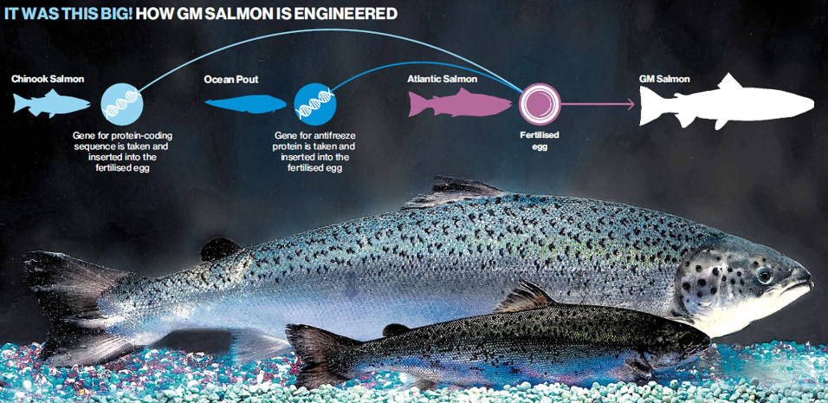

Animal Farm: A Technological Revolution
1972: Scientists use special enzymes to snip fragments of DNA – genes – from one microbe and insert or "recombine" them into another microbe. The revolution in recombinant DNA begins with the creation of the first GM organism.
1980: Laboratory mice with genes inserted from other individuals become the first genetically modified "transgenic" animals. Dozens of other experimental species, from pigs and chickens to frogs and fish, follow over the next two decades.
1989: The AquAdvantage founder salmon is created by micro-injecting a fragment of DNA from an ocean pout fish and a Chinook Pacific salmon into a fertilised Atlantic salmon egg.
1995: AquaBounty Technologies begins the lengthy process of applying for official US Government approval to develop the AquAdvantage salmon commercially.
2002: The first commercially viable GM animal is created from two species by Nexia Biotechnologies in rural Quebec. The "spider-goat" has a single gene from a golden orb-weaving spider which means its milk contains spiders silk, five times the strength of steel, which is used for making bullet proof vests.
2009: The US Food and Drug Administration issues its final guidance to the GM industry on rules governing the regulation of genetically engineered animals, which clarifies its status as the chief statutory and regulatory body for GM animals.
2011: British scientists create chickens which don't spread bird flu by inserting an artificial gene that introduces a small part of the flu virus into the bird. This gives them the virus, but prevents them from spreading it.
2012: A genetically modified cow in New Zealand is the first to produce milk with no Beta-lactoglobulin (BLG), the protein that is thought to be responsible for allergic reactions. Meanwhile, Chinese scientists create a GM cow whose milk includes omega-3 fats, normally found in fish.
May 2012: The US Food and Drug Administration completes its environmental assessment of the GM salmon but delays publication of the draft report until 21 December 2012.

